EXPERIMENT 8 MARKS PERCENTAGE

Step1: Creating an application called as ‘Student Counselling’

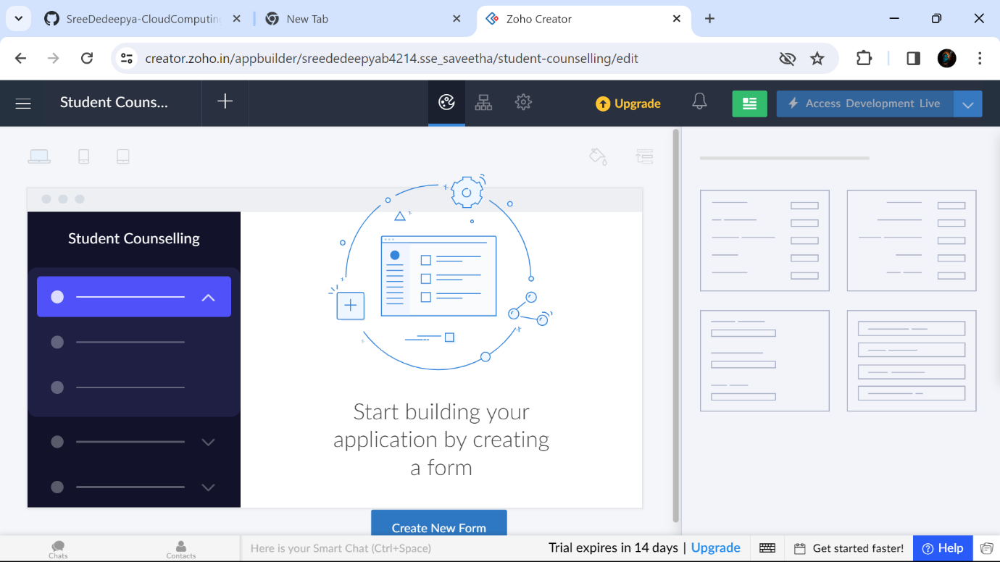

Step2: Creating a form as ‘Student Details’

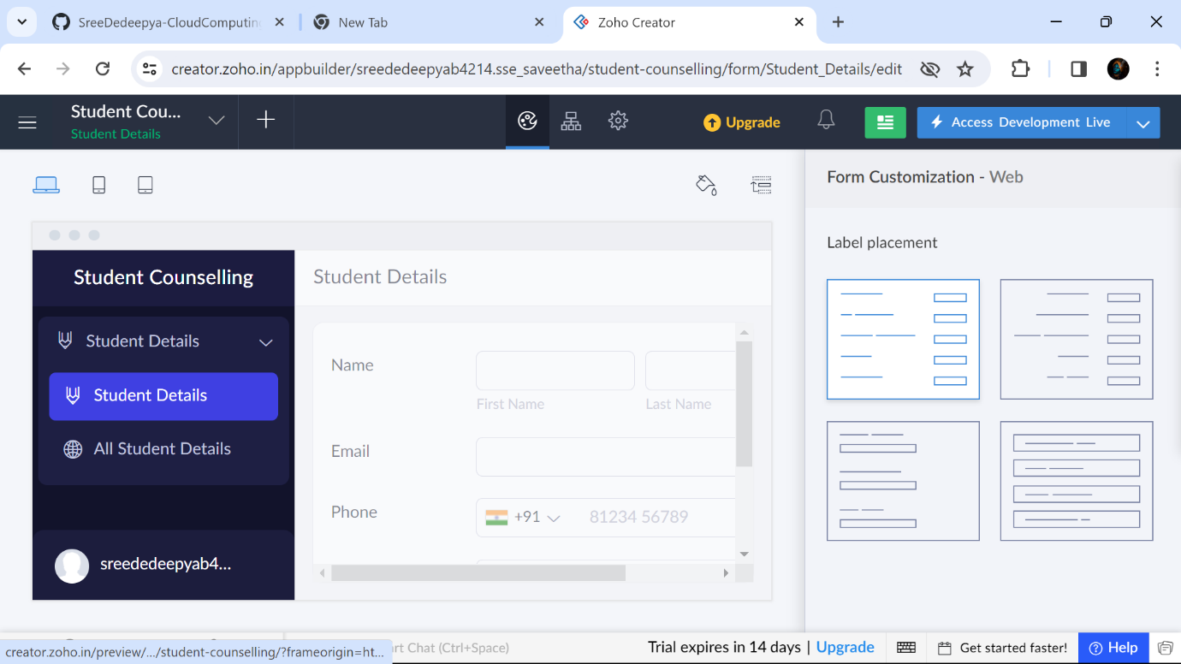

Step3: Creating a form as ‘Student Course Details’

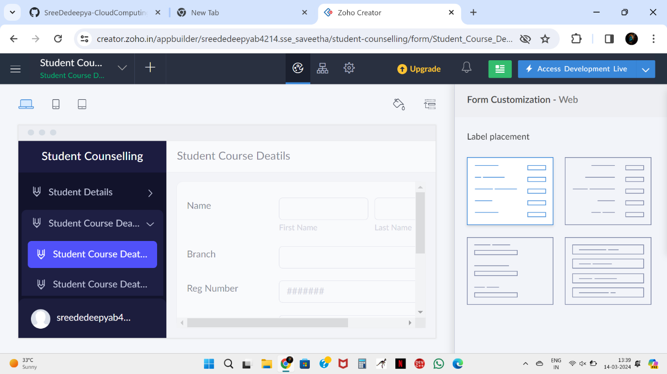

Step 4 : Creating a form as ‘Mark Percentage’

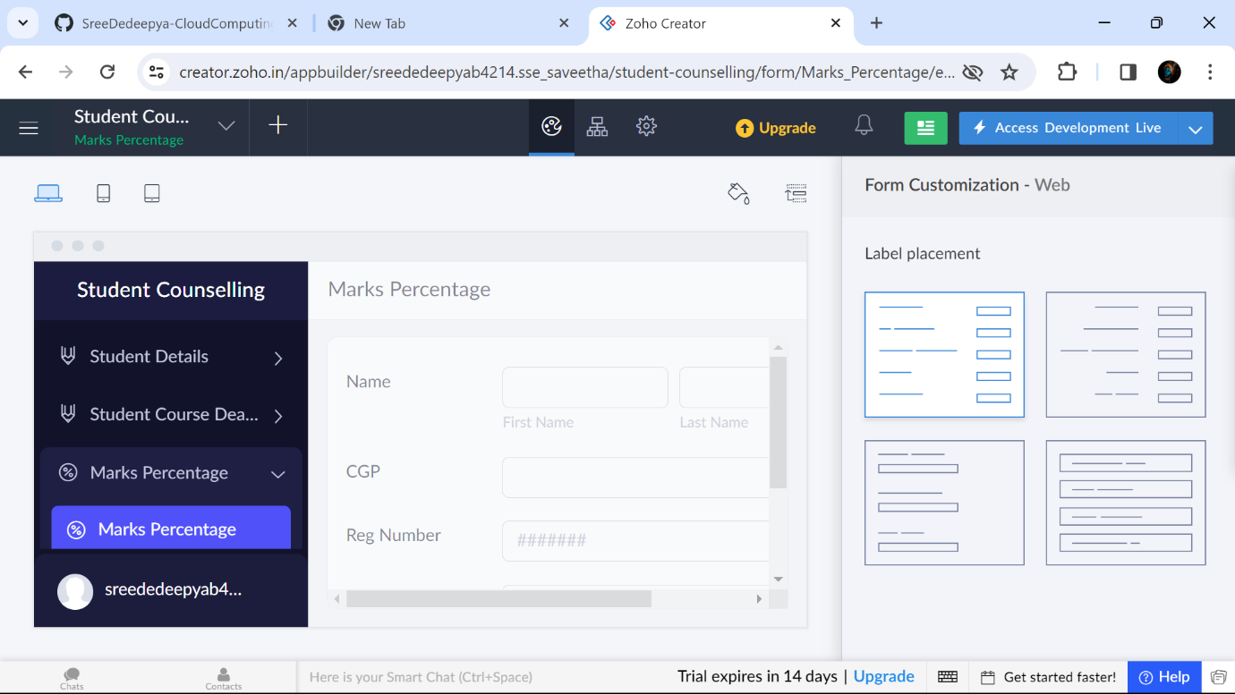

Step5: Displaying the details in ‘Student Details’

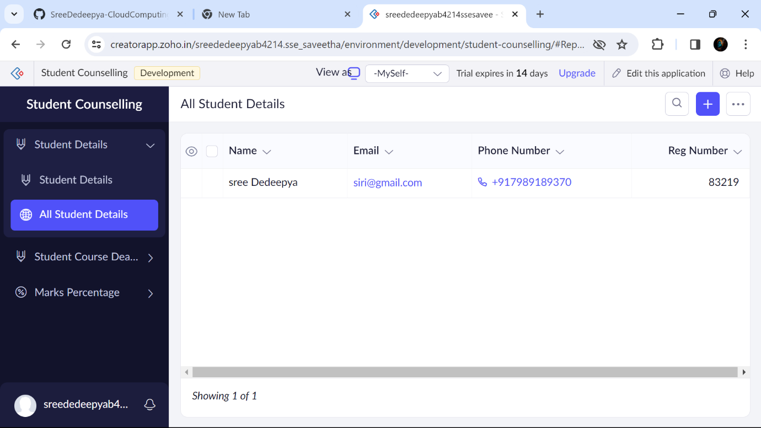

Step 6: Displaying the details in ‘Student Course Details’

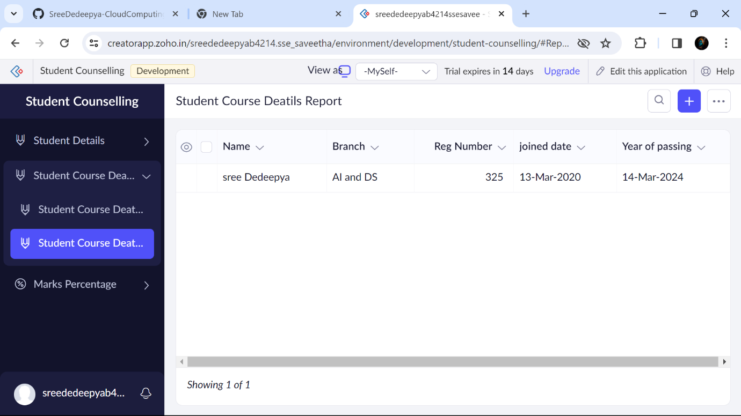

Step 7: Displaying the details in ‘Marks Percentage’

